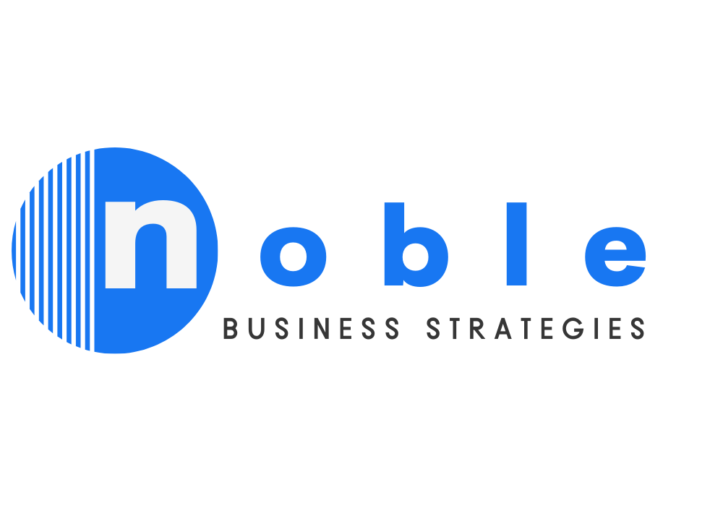
Unique Selling Proposition and Guarantee
Business Owner Worksheet

Welcome to the Unique Selling Proposition and Guarantee Questionnaire. This questionnaire will help you discover or develop your competitive advantage or value proposition and a strong guarantee that removes the risk of doing business with you in the minds of your prospects. A good USP is much more than “we provide good service at a competitive price.”

You need to articulate what makes you truly unique when compared with your competitors.Your guarantee needs to put the onus on you to do business in a way that gives your customers the confidence that their worst fears will not be realized when they do business with you them .

Any good USP must consider who your prospects are, how they think, what’s important to them when they buy, what exactly they need and want, etc.

The following questions are designed to get you thinking about your prospects. Please answer them as precisely as you can:

- What scenarios or situations make your prospects first consider buying what you sell?

- What needs, frustrations, fears, or pain do your prospects experience that motivate them to buy?

- What do your prospects feel they need and expect as a result of their purchase?

- What would your prospects be delighted to receive due to their purchase if they could reasonably expect them?

- What problems, frustrations, or challenges do your prospects expect to face when dealing with your industry in general (e.g., trades-people showing up late or leaving a mess or service professionals not returning phone calls)?

- What potential problems, frustrations, or challenges do your prospects dread when they think of buying what you sell?

- What would be good for your prospects to know as they make their buying decision that is not typically understood about your industry?

- How is your company positioned to deliver not only what your prospects expect uniquely, but also what will delight them?

- What kind of data will give your prospects assurance about their buying decision?

- What kind of data can you give your prospects to emphasize the uniqueness of your company?

- What assurance can you give your prospects that they will not experience what they dread if they buy from you?

- What assurance would you like to be able to give your prospects that they will not experience what they dread if they buy from you?

My Unique Selling Proposition:

My Guarantee:

